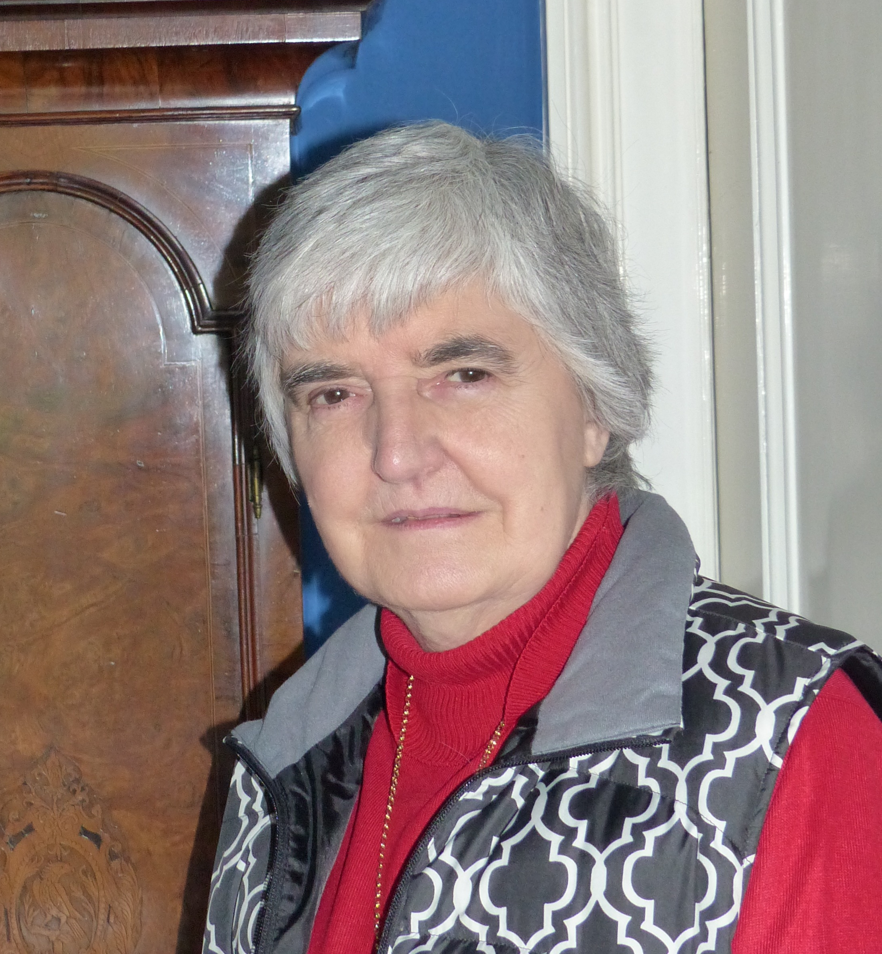
Boyle Linda

Index number: MWOH002004

Recorded on: Wednesday 13th January 2016 by Anne Weaver and Roger Davis
Time commenced: 11.00 Duration: 32 minutes Location: Rose Cottage. London Road, Mickleham.

Linda was born in 1945. At the time her mother was living with her parents in Merton, whilst her father was undertaking his National Service in Israel. When Linda was 5 the family moved Mitcham, living next door to her paternal grandparents. They remained there for approximately 11 years before moving to a council house, also in Mitcham. After her marriage to Michael they lived in Sutton but have now lived at Rose Cottage for the last 39 years. She recalls that her paternal Grandparents grew vegetables; kept chickens and that her Grandmother was a good cook. Linda then tells us that as there wasn’t a fridge in the house in Mitcham, they would obtain a metal ice cream container from the local corner shop and bury it in the garden to store food in it. She goes on to tell us about shopping at the local store where provisions such as sugar were weighed and placed in paper bags. Ice cream however was only for special occasions such as birthdays. We then hear about Linda’s dislike of chickens and other birds and of her reluctance in helping with their care. Linda then describes her favourite meals and the food provided at her wedding reception. She recalls Christmas lunches and the fact that her father did not get involved in food preparation. Other than picnics she has no recollection of eating out until she was older and working at the BBC. The domestic set up during early days of marriage is described including the larder and Linda then goes on to tell us of her children’s involvement in the kitchen chores, mainly washing up. We hear how Linda’s cooking has changed over the years and of her love of baking but that she dislikes ready meals. She comments that whilst working at the school in Mickleham, she observed that many children where not used to using cutlery and she believed that they would eat at home in front of the TV – something that she did not approve of. In conversation Linda then recalls her childhood shopping in the markets in Tooting or Surrey Street Market, Croydon. She mentions shopping in the original Sainsbury’s Stores, the advent of supermarkets, and buying tea and coffee. She tells us how Leatherhead has changed and that she regrets the loss of independent shops such as butchers, greengrocers and bakers.

