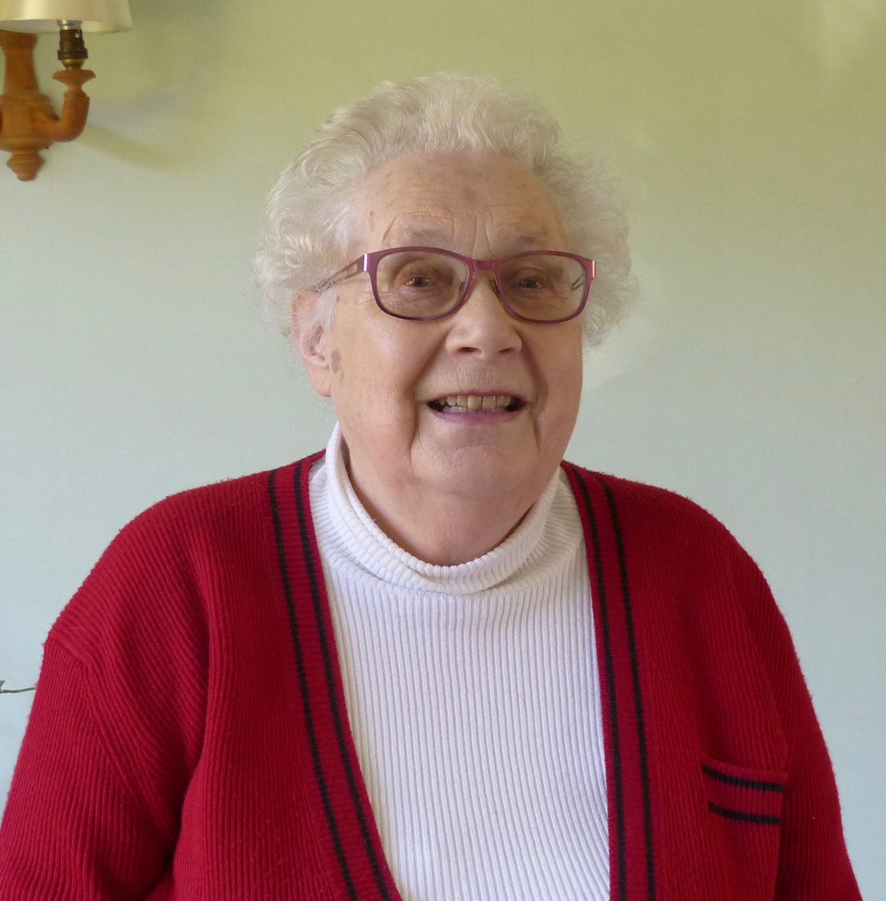
McMillan Clare
(Born: October 1934. Maiden name: Arthur)
Index number: MWOH002008

Recorded on: Tuesday 29th April 2016 by Anne Weaver and Roger Davis
Time commenced: 10.45 Duration: 31 minutes Location: Kent’s Meadow, 3 Milton Avenue, Westcott.
Clare starts by telling us that although she wasn’t born in Westhumble, she grew up in the village and stayed there until 1950. Her father was the landlord of the Railway Arms public house, as was her Grandfather before him. Next we then hear a little of the family history and she tells us that it was an interesting place to grow up, especially with the onset of the war and the arrival of Canadian Soldiers in the area. She then mentions their sudden departure at the time of the D Day landings. We are told how the advent of rationing during the war meant that Clare’s mother had to keep accurate records of the meals and beverages served in order to buy grocery supplies. She describes the lunches and teas, which were supplied at a set price, often to local residents, and how the perishable food was stored in a refrigerator. Clare then tells us about the delivery of the groceries from Kinghams, Dorking and milk from Prewett’s Dairy, Leatherhead. She was expected to help in the kitchen, making tea, buttering bread, and washing up. She also helped to prepare salads - these often would contain boiled eggs but occasionally salmon, and we hear how the fish was either obtained locally from MacFisheries or more rarely from Billingsgate. Following this we hear about the staff of the Railway Arms, both in the kitchen and the waitresses. Days off for Clare’s parents were rare and she has no recollection of family days out. Opening hours were restricted and strictly adhered to. Children were not allowed in the bar, they might occasionally be found in the restaurant, but more likely they would sit outside. Returning to the presence of Canadian soldiers we are told that they were well behaved and more affluent than the British troops. Clare tells us that there was always a demand for the food served, as it meant that the diners would be able to avoid using their own rations. Next we hear of an occasion when, on a very busy day, more bread had to be borrowed from the Burford Bridge Hotel. She then relates about visits by the then Home Secretary, Chuter Ede, who as well as having a celebratory lunch following the re-opening of the Stepping Stones, would also visit with his wife for Sunday lunch. We are then given a description of the layout of the Railway Arms and its division into Public Bar, Salon Bar and Restaurant, and we hear a little about some of the clientele, both locals and day-trippers. We are told of other enterprises, carried out when Clare’s Father in Law was the Landlord. These included cleaning knives for Mrs Greville’s household at Polesden Lacey and of providing the horse and cart rides from the station to Polesden Lacey for the estate’s staff. The horses were stabled behind the pub and were also used to take day-trippers to the top of Box Hill. Also attached to Railway Arms was a kitchen garden that supplied vegetables for the restaurant, although these were also bought from Mr Potter when he came on his horse and cart from Pixham Lane. The garden was also home to about 20 chickens that supplied eggs that were often used to make cakes.

