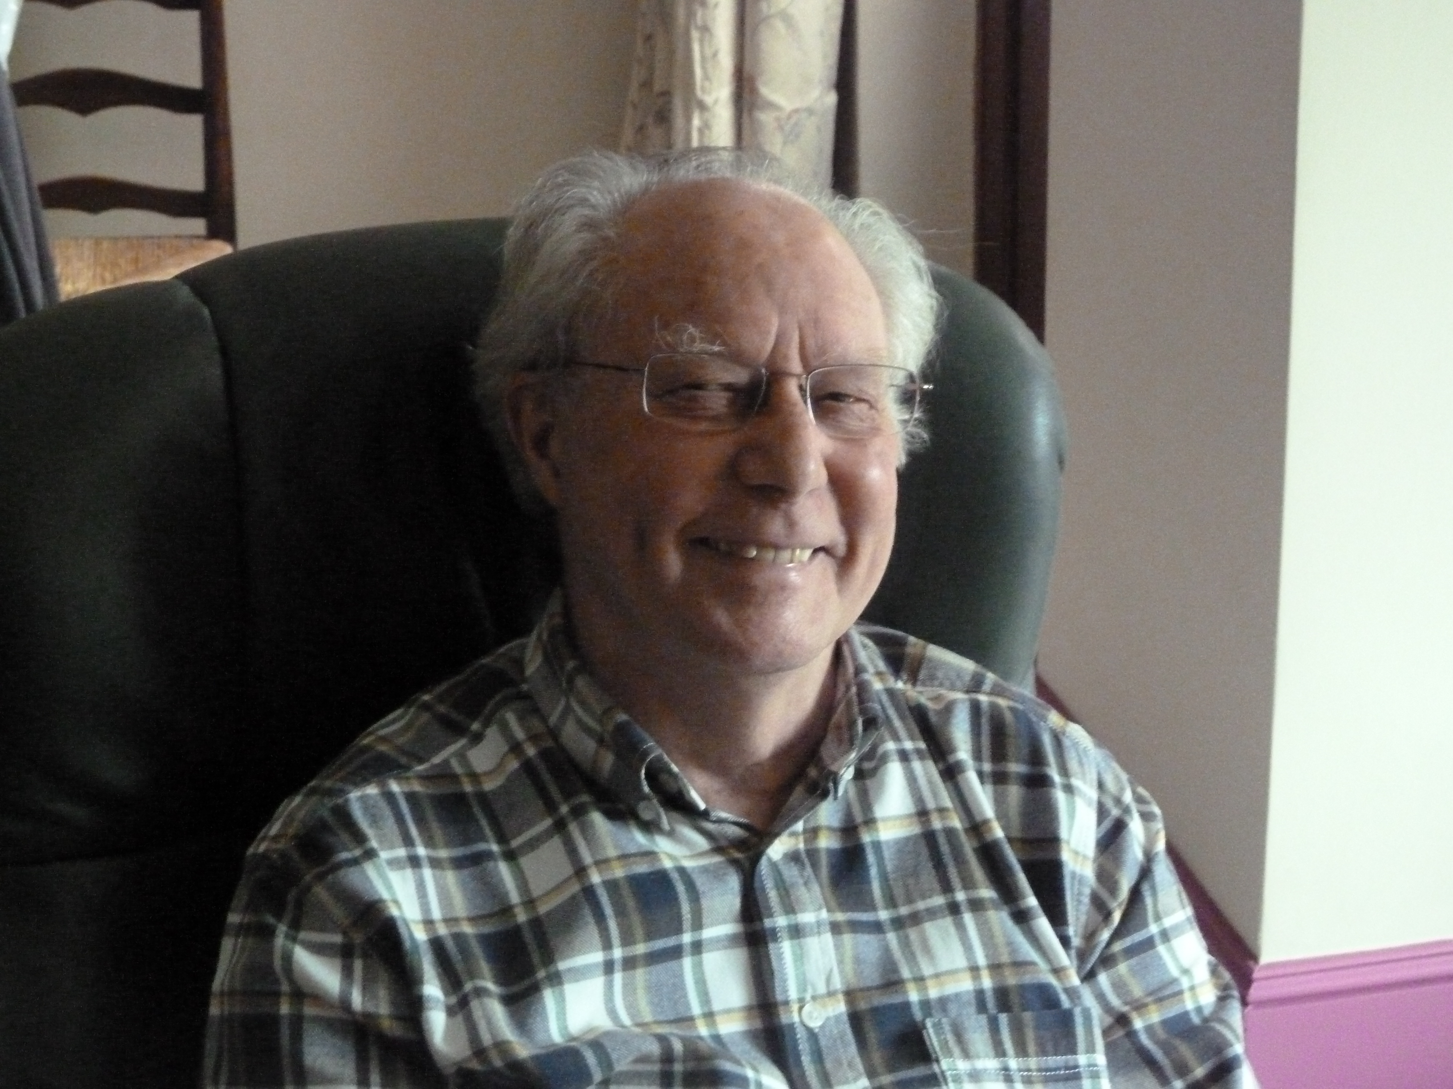

Soden John

Index number: MWOH002002

Recorded on: Wednesday 25 November 2015 by Anne Weaver and Roger Davis
Time commenced: 11.00 Duration: 25 minutes Location: Hillcot , Chapel Lane, Westhumble.

John was born in 1931. His parents lived in Hounslow. He subsequently moved to Teddington, then later to Dorking when the engineering company that he worked for transferred to the area. Finally he moved to Westhumble in 1985. He tells of his war time childhood, including his evacuation to a farm. He recalls helping with food production on the farm and of his upset when a pig was slaughtered. Despite wartime rationing John enjoyed the food provided by the Farmer’s wife and he has remained in contact with the family ever since. Back at home although he did not help in the kitchen he remembers food being delivered including on one occasion the rare treat of bananas. Friends and neighbours would club together and sometimes extra food could be obtained – John gives the example of some meat from someone who worked in a butchers and he stresses that food would not be wasted. Teatime was his favourite meal and he reminisces about the cakes and buns special meal and his family would often go to his Grandmother’s for this. At this time John tells us that most food was delivered weekly and that they did not go out to eat. His primary school was close enough to home to be able to return home for lunch but after the age of eleven he was at grammar school and took school lunches, which he enjoyed. He recalls one special occasion when his parents were taken out by their children for a Chinese meal in Richmond. We then hear about John’s National Service which he started at age 23 and felt was a waste of time. Returning to his childhood we are told how he learnt about gardening by helping his Grandfather who was a retired market gardener. He used these skills in his parent’s garden, which had been turned into a vegetable plot, and later furthered his interest in farming by joining the Young Farmer’s Club at Grammar School. We then hear how John started to methodically prepare meals when he retired and of his skills as a cake maker. Now meals are cooked by his wife Jean using fresh, locally source food wherever possible. We then hear about John’s role in the design of machinery for the manufacture of large wire coils for the first MRI scanners.

