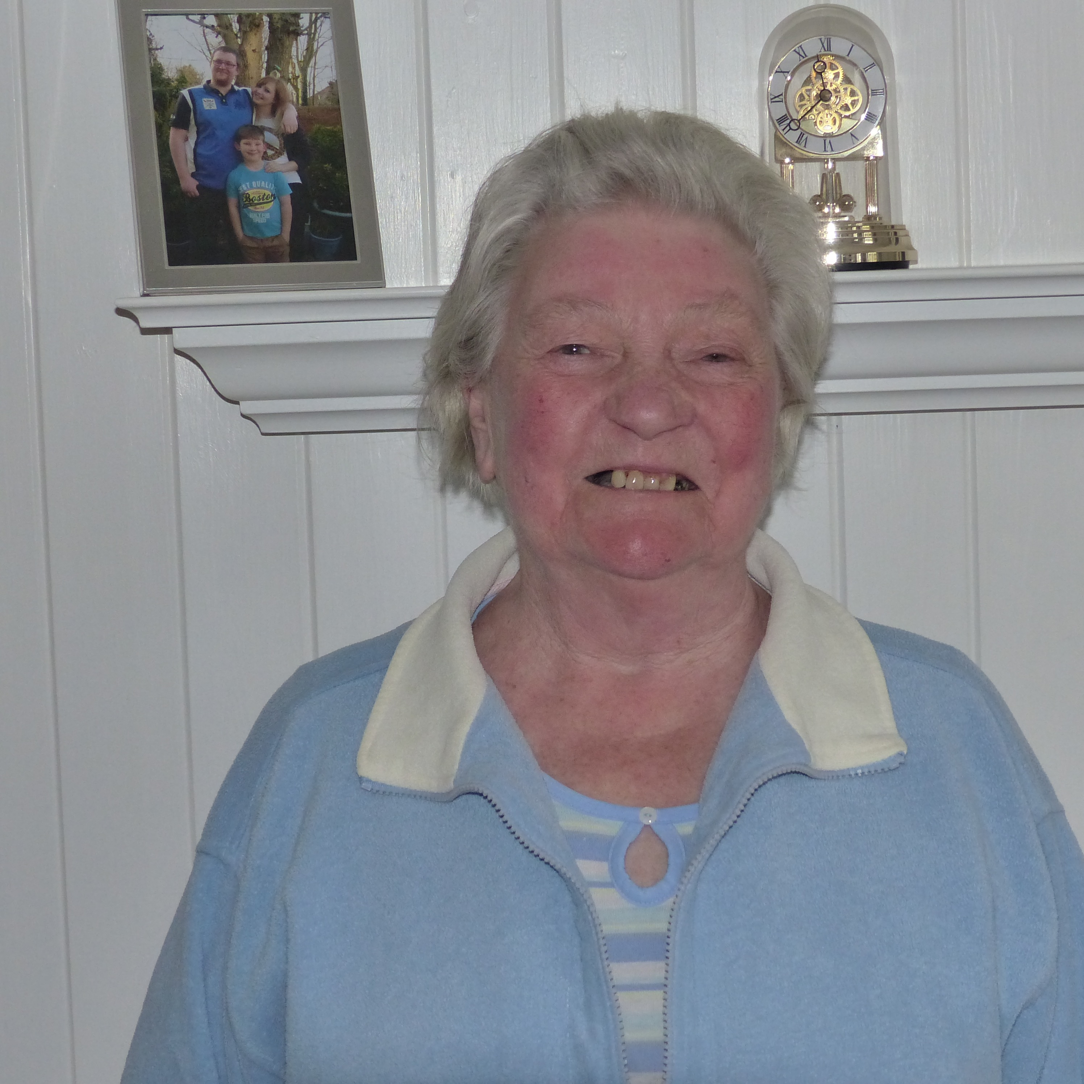
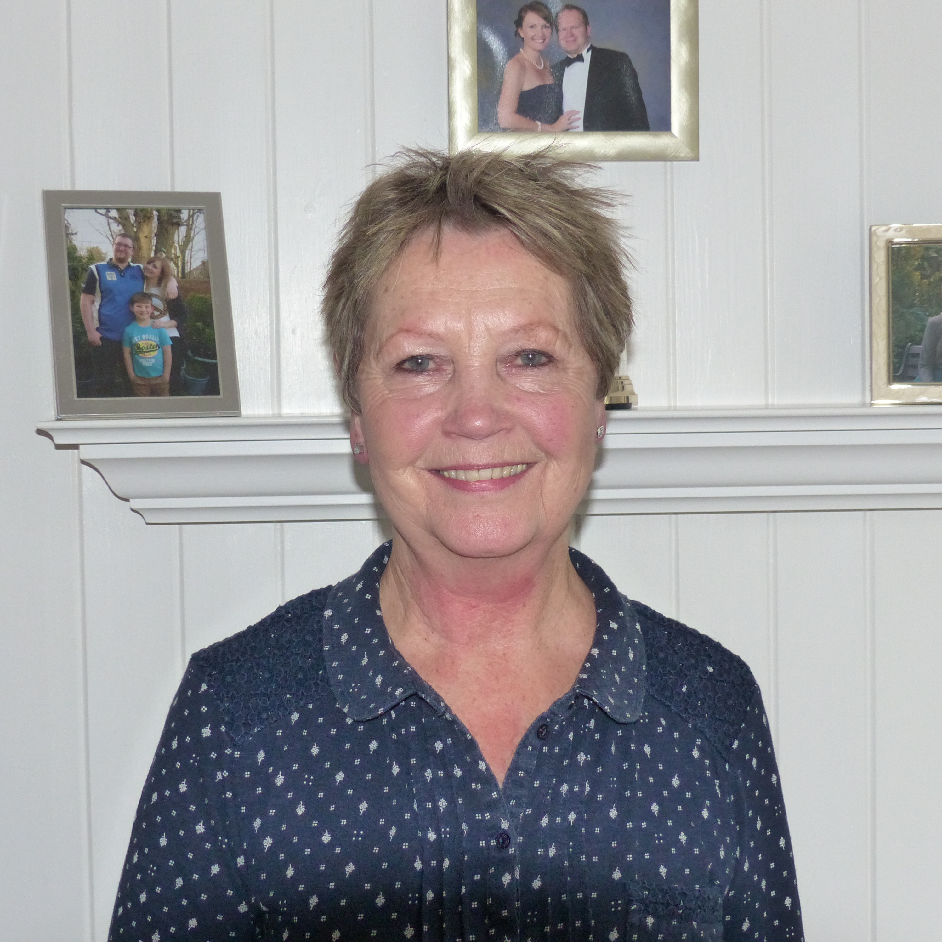
Roberts Wendy
Wishart Shirley
Index number: MWOH002006

Recorded on: Monday 22nd February 2016 by Anne Weaver and Roger Davis
Time commenced: 10.45. Duration: 40 minutes Location: 30 Middle Road, Leatherhead.

Wendy was born in 1949. She lived in Dell Close, Mickleham, initially at No 8 but as the family grew they moved to a larger house, No 12. They kept chickens and grew vegetables. Her father was a farmer who tended the vegetables plot at home. He also brought home vegetables from work as well as and 7 pints of milk a day. Her mother went out to do cleaning and was responsible for all the cooking at home. We are told that she was a good baker but that the food was very basic. Wendy then describes the sort of food that they ate regularly, from Sunday roasts to cheaper cuts of meat and dishes such as bacon and onion roly-poly or corned beef fritters, in the week. Milk puddings were eaten most days with fruit and evaporated milk on a Sunday. Often bread and warm milk was eaten and sugar or jam sandwiches are mentioned. Most of the shopping was done at the Village Store, from which there was a weekly delivery. She also recalls the delivery by the baker’s van. Wendy thought that fresh meat came from the butchers in Leatherhead. She emphasises that there were no fussy eaters & that they had to eat everything that was put in front of them. Weekends were often spent at her Grandparents at Hall Farm, which was behind the Running Horses pub. At this time, as refrigeration was not available, shopping had to be done frequently. The food was then stored in a larder or in a meat safe such as the one kept on a marble slab at Hall Farm. Baths were taken once a week as there was no supply of running hot water but instead had to be heated in a copper. Returning to mealtimes we are told that the family all sat down together at 5.00 pm to eat and that the children were expected to help in the kitchen. As they lived close to the School they could return home for lunch but this changed when they went to secondary school. Wendy says that they did not eat out at restaurants but she recalls the Christmas tea that was provided at the home of Sir Raymond and Lady Jennings in Mickleham. At home Sunday tea was usually salad and tinned meat such as Spam, or off cuts of ham. Summer evenings were usual spent with all the other village children on the rec, climbing trees, playing rounders and eating cake. Another treat were the occasion trips to the King William pub where fizzy drinks and crisps were consumed in the garden.

Shirley was born in 1934 and lived at Park Farm, Chessington but at the age of 2 she moved to Hall Farm, Mickleham. She then lived at Highlands Farm, Headley from age 8 to 10 before returning to Hall Farm, where her father grew vegetables all year round as well as producing milk from the dairy herd. Her mother then delivered the milk around the village. We also hear that her mother cooked for several local houses such as Juniper Hill, and that in the war she was a fire warden. We then hear about a ghost at Hall Farm and about the farm’s role as a stable for coaching horses. Shirley tells us about the deprivations of food rationing in the war, the lack of meat and fruit, but that fresh bread was delivered weekly. The types of meals cooked by her mother are listed and then mention is made of buying meat from Leatherhead, followed by some recollections of the schools she attended. We are told that rationing meant that there was little provision for meals at special occasions, but that butter was made on the farm and that as a farmer, her Father received an extra ration of cheese. Attention then turns to the basic living conditions including outside toilets, gas lighting and, as there was no electricity supply, a radio powered by an accumulator that had to be taken to be recharged. We hear how Shirley learned to cook from her mother and she goes on to tell us how, over the years, she became very independent, leaning to do handywork, including building a brick wall.

In general conversation with both Wendy and Shirley we hear that holidays were few and far between. The families long association with Highland Farm & the Woodall family is discussed. Wendy explains that 3 generations, Grandfather, Father and herself, had worked for the Woodall’s, totalling 100 years service. Shirley talks about helping at the farm when she got home from school, her proficiency at driving from an early age and how the silage was treated and collected. She then tells us about how she would buy and rear day old chicks which where then sold at Christmas. Rabbits were also reared and eaten for their meat. Another enterprise that we hear of is the picking of mushrooms from the lucerne crop, which were then sold to the local hotels. Shirley also delivered telegrams for the post office for 1 penny. Wendy tells us how she and other children would help with the potato harvest, being paid a shilling a bag. She then recalls the orchard at the back of Hall Farm where a Gypsy called Black Ada lived in an old fashioned caravan. Conversation then turns to the replacement of Hall Farm with a block of flats. We hear of horses being broken in and shod at Hall Farm, and tales of riding on the milk float to and from Highlands Farm. In the haymaking season the children would have tea and then be driven back home on top of the hay bales on the trailer. Finally there is a discussion about the family’s involvement in milk production on the local farms and how it was bottled and distributed.

