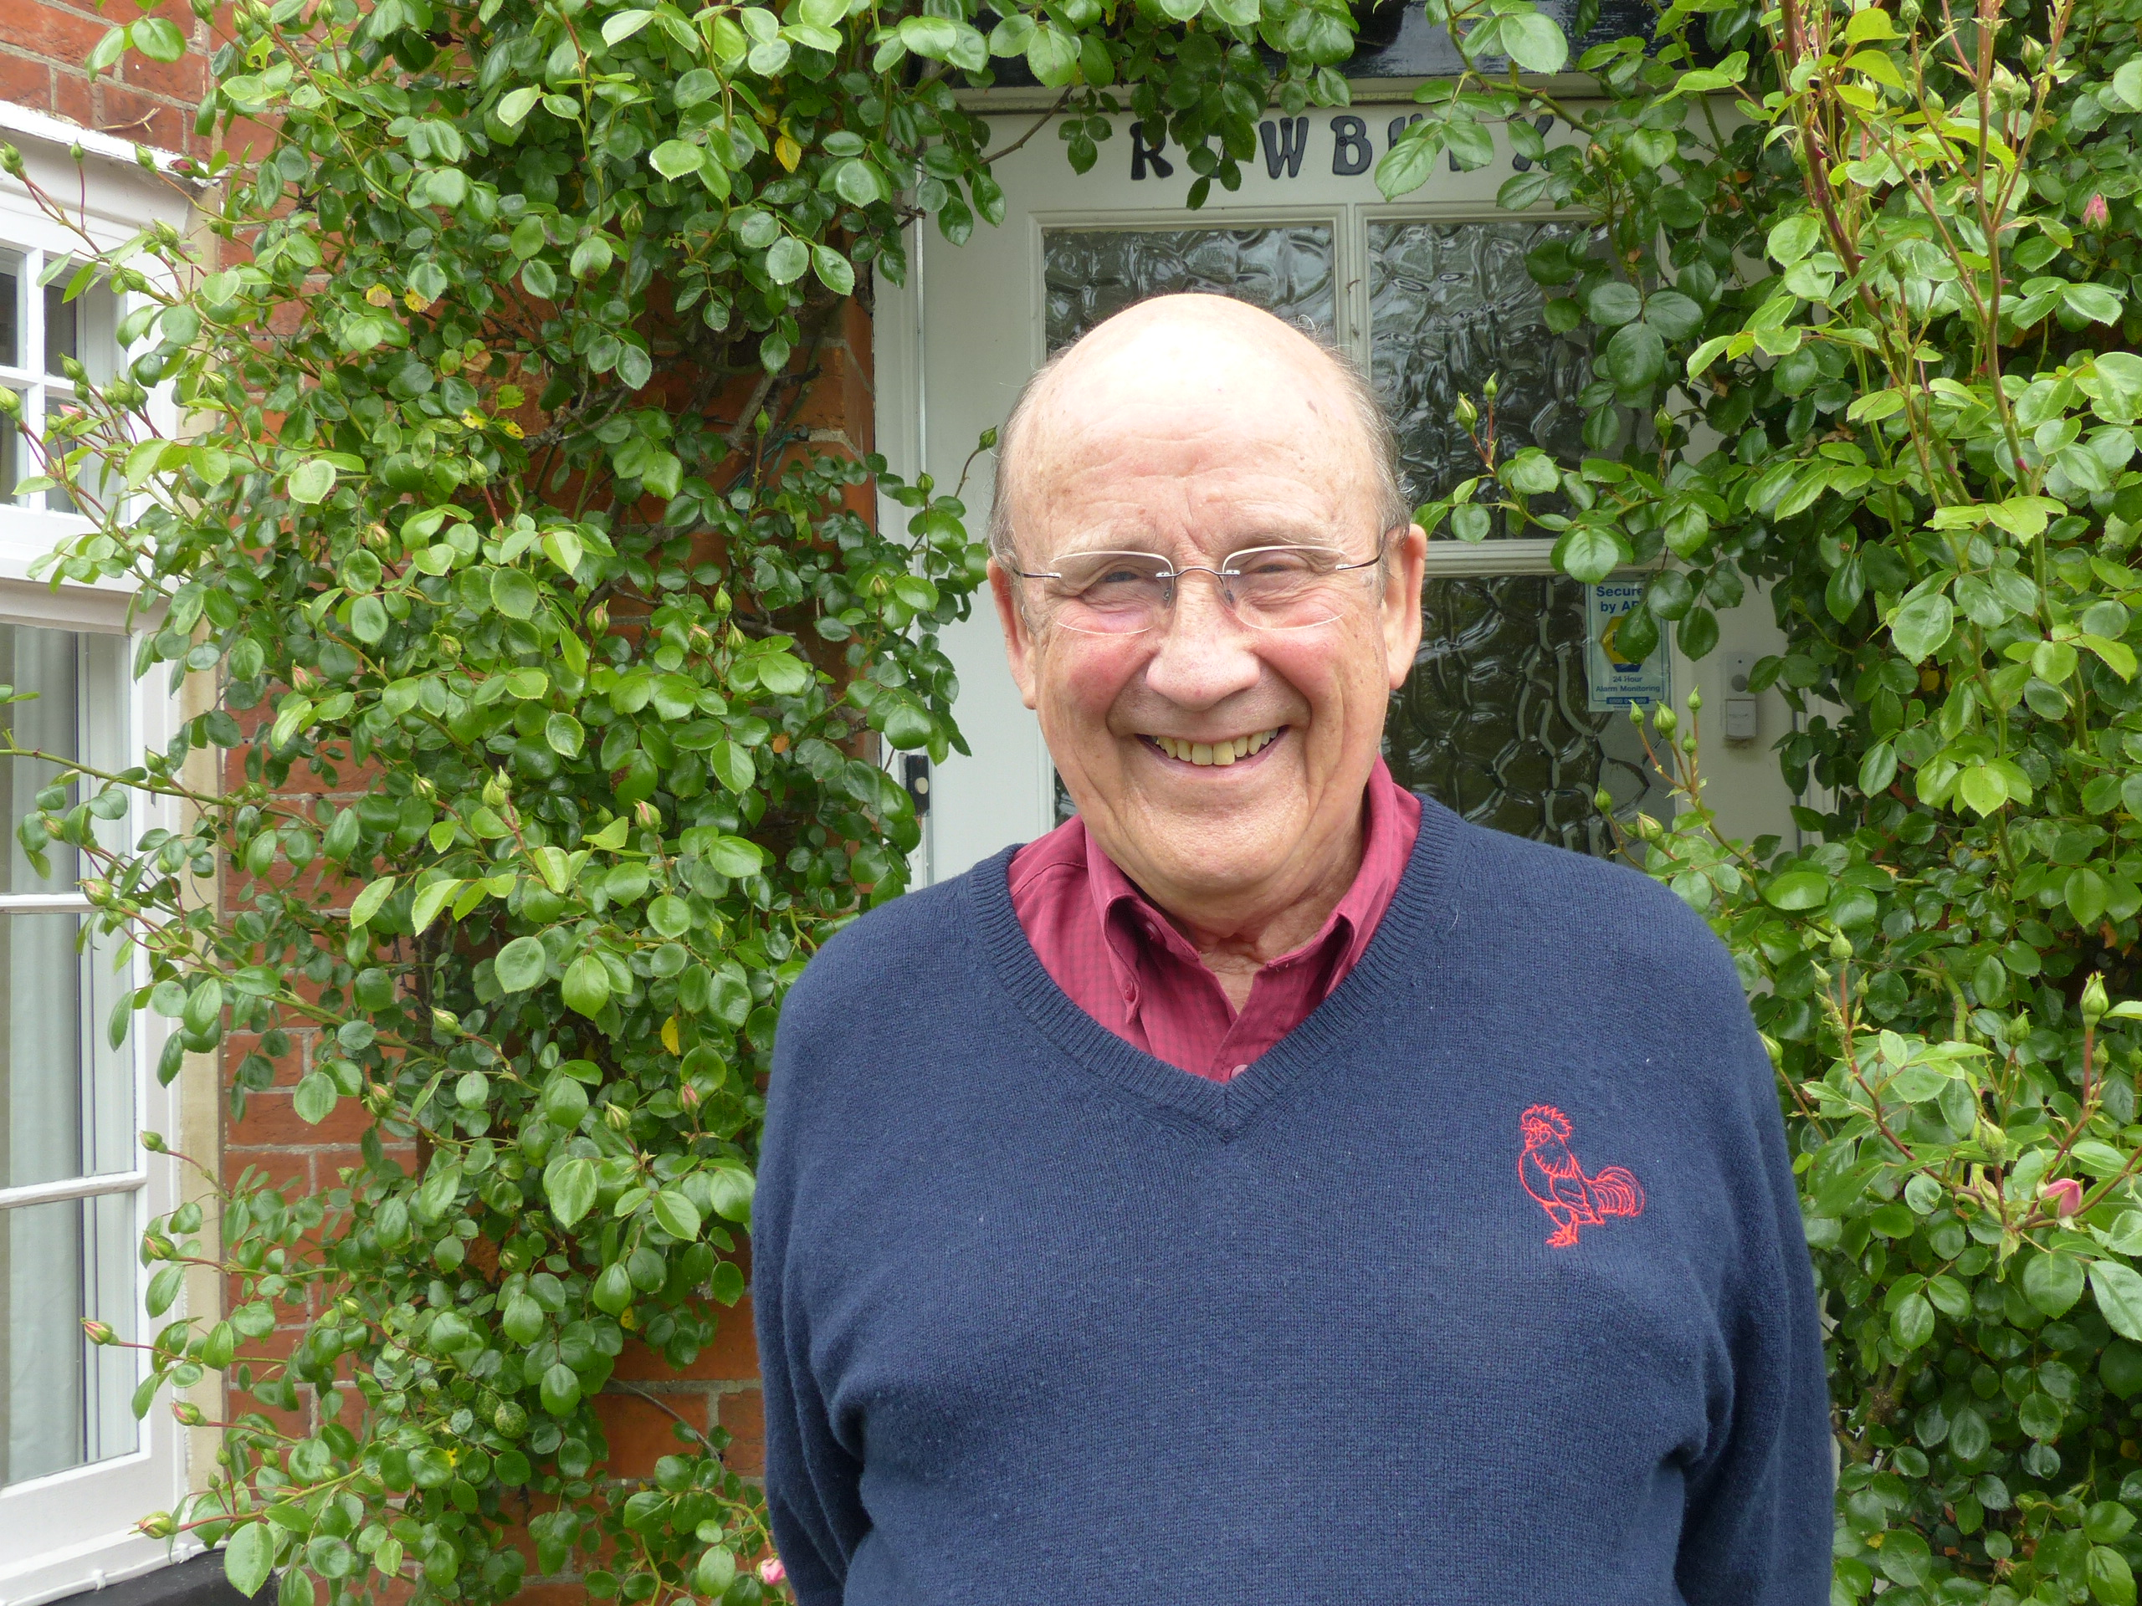
Grieve Derek

Index number: MWOH002012

Recorded on: Thursday 2nd June 2016 by Anne Weaver and Roger Davis
Time commenced: 11.00 Duration: 40 minutes Location: Rowbury House, Pulborough, West Sussex

Derek was born in Fetcham in 1935. He was an only child and the family moved to Leatherhead in 1937. In 1940 his father left his job in Fleet Street to join the RAF and Derek and his mother moved to Burney House, Westhumble to join his Aunt and Uncle, Vera and James Simpson. His father was posted to India but on his return and demob in 1946 he bought a house, The Old Orchard in Burney Road. Asked about his earliest memories of Westhumble Derek tells us that his Uncle and Mr. E J Baker, owner of a motor business in Dorking, removed a section of Camilla Lacey to make two dwellings of which Burney House was one. We hear of a reinforced shelter built in the cellar that the family and neighbours would sleep there during the bombings. Derek then recalls bomb damage in Leatherhead, hunting for shrapnel near his Great Uncle’s home at Melton Hall in Newdigate, fire precautions in Westhumble to guard against incendiary bombs and of some near misses with flying bombs. In 1941, age 6, he went to Stanway School initially as a day boy becoming a boarder after 2 years before moving to Epsom College when he was 12 ½ to complete his education. Next we hear how Derek developed his interest in motorcars and of a minor accident in his father’s car. Following his 2 years national service in the Navy, Derek started to work at E J Baker, staying for 10 years before moving to Mays where he stayed for the rest of his career. He describes how his career developed through the various departments at E J Bakers before he was approached to become Sales Manager at Mays. He tells us that he lived in Westhumble from 1940 to 1963, leaving when he married. Returning to the war years Derek recalls the use of the A24 to store army vehicles in preparation for D-Day. At home most of the food was ordered over the phone and then delivered from either Roses Store or from shops in Dorking. Food was plentiful when staying with his Great Uncle as he had hens, pheasants and plenty of rabbits and we hear of staff being summoned to the table when a foot operated bell push was used. Reflecting on growing up in Westhumble Derek talks of rationing, how food had to be eaten up and he mentions his favourite food. At school he enjoyed baked beans on fried bread, except on the occasion that they had been sneezed on by the teacher!
Aspects of school life, including trips to church and the names of teachers, are described. Mention is made of some of the neighbours including Ronnie Shepherd, his daughter Rosalind and friends Muriel Edmonds & Phyllis Strong, and the games played. Chickens were kept in the grounds of Camilla Lacey and Burney House and in the nearby woods emergency rations were stored underground in what may have been a disused icehouse. Derek tells us that his Uncle and his neighbour Ernest Baker were responsible for starting a scheme for regular giving to St Michaels Church. Returning again to wartime memories we hear about the military vehicles on the A24, the construction of Young Street by Canadian soldiers, the storage of ammunition near Newdigate (where incidentally a Turkish airliner crashed many years later) and of an huge explosion near Friday Street again from stored ammunition. This prompts Derek to tell us how his Great Uncle’s property at Newdigate lost value after the announcement of the development of Gatwick Airport. He then recollects the farming on the Melton Hall Estate, including the harvest and a day spent on a tractor. Next Derek tells us of a Hillman Minx driven by his Uncle that had been supplied to the actor Leslie Howard by F W Mays. Talking about his ancestors we hear that his Great Grandfather was the landlord of the Running Horses in Mickleham and of how Derek’s Grandfather would travel to London to wash the cups of the tea tasters in Mincing Lane and of his lunches in Smithfield Market. He then worked for a local brewery but was made redundant from his post of secretary and from the war years until his retirement ran a Sweet shop in Bell Street, Reigate.

